Soundboard Optimisation Report

Case 1: Running Optimisation After Splitting the Bracing Type Data into Parallel and Cross

Used predictor: gaussian process with combination of two kernels
- Numerical: Squared Exponential
- Nominal: Hamming Distance

Estimation Method : Maximum Likelihood

Internal Parameters of predictor :
Hamming Distance
  - Categorical LengthScale= 0.11206,
  - Signal Standard Deviation= 3.4792
Squared Exponential
- Numerical LengthScale = 0.199352,
- Signal Variance=0.262686
WN
- Noise Variance =0.00138062

Results
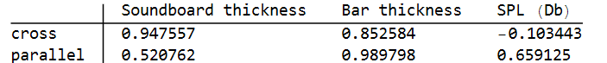
Figure 1 optimisation results
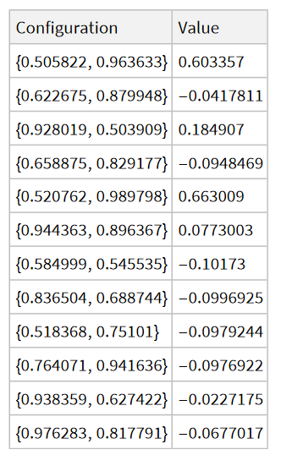
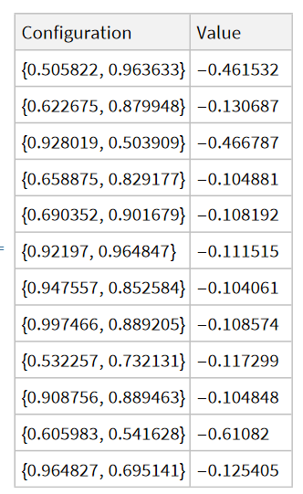
Figure 2 Evaluation History for parallel
Figure 3 Evaluation History for cross

Case 2: Running Optimisation directly without splitting data

Used predictor: gaussian process with combination of two kernels
- Numerical: Squared Exponential
- Nominal: Hamming Distance

Estimation Method : Maximum Likelihood

Internal Parameters of predictor :
Hamming Distance
  - Categorical LengthScale= 0.11206,
  - Signal Standard Deviation= 3.4792
Squared Exponential
- Numerical LengthScale = 0.199352,
- Signal Variance=0.262686
WN
- Noise Variance =0.00138062

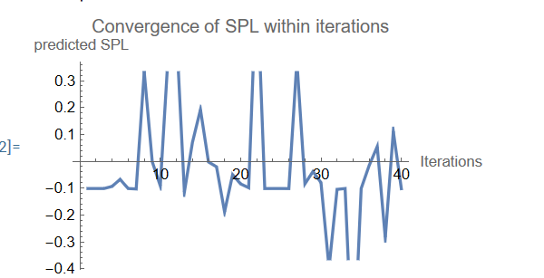
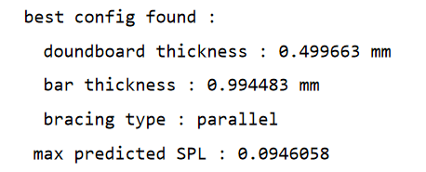
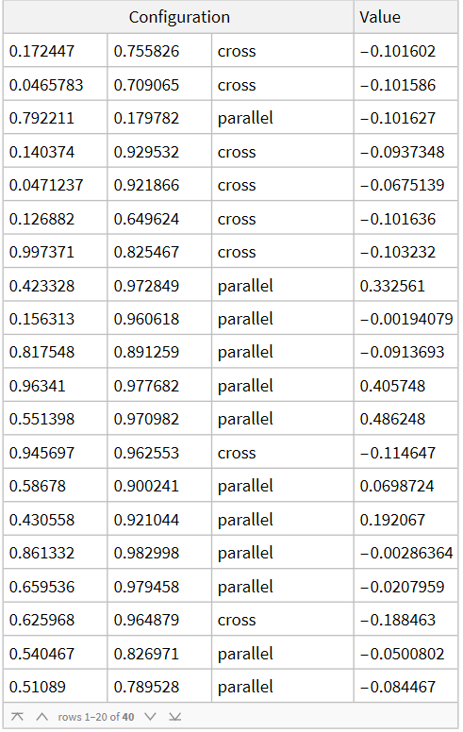
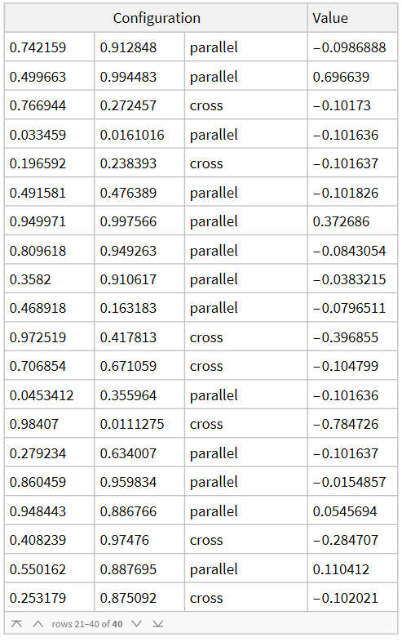
Results
Figure 4 Evaluation History during the optimisation from (40 evaluations)

